**import** javax.swing.JOptionPane;

/*

* Justin Mendes

* Created: September 14, 2017

* Last Edited: September 14, 2017

* Unit 1 Activity 1 Program/Question 1

* This program will display the outputs of a number used in trigonometry functions (USING MATH CLASSES)

*/

**public** **class** Trigonometry

{

**public** **static** **void** main(String[] args)

{

//Variable Declarations and Initializations

**double** userInput;

userInput = Double.*parseDouble*(JOptionPane.*showInputDialog*(**null**, "Trigonometry Ratios\n===============\n\nEnter a number that will "

+ "to show the output of it going through trigonometry ratios", "Trigonometry", JOptionPane.***QUESTION_MESSAGE***));

System.***out***.println("The cosine of " + userInput + " is: " + Math.*cos*(userInput) + "\nThe inverse cosine of " + userInput + " is: " + Math.*acos*(userInput) +

"\n\nThe sine of " + userInput + " is: " + Math.*sin*(userInput) + "\nThe inverse sine of " + userInput + " is: " + Math.*asin*(userInput) +

"\n\nThe tangent of " + userInput + " is: " + Math.*tan*(userInput) + "\nThe inverse tangent of " + userInput + " is: " + Math.*atan*(userInput));

}//end main

}//end class

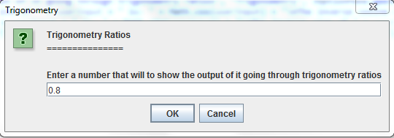

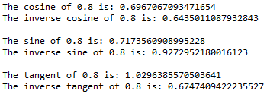

/*

* Justin Mendes

* Created: July 29, 2017

* Last edited: September 14, 2017

* Unit 1 Activity 1 Program/Question 2

* This program will find the date of the Easter in the given year

*/

**import** javax.swing.*;

**public** **class** EasterVariation2

{

**public** **static** **void** main(String[] args)

{

//a - m - the quotients and remainders needed

**int** a, b, c, d, f, g, h, j, k, n, p, q;

**int** month; //Easter month

**int** day; //Easter day

**int** year; //Easter's year

String monthStr;

//Ask user for year

String yearStr = JOptionPane.*showInputDialog*("Easter "

+"Date Calculator\nPlease enter a year");

//Convert the year from a String to an int

year = Integer.*parseInt*(yearStr);

//Calculations

a = year / 100;

b = year % 100;

c = (3 * (a + 25)) / 4;

d = (3 * (a + 25)) % 4;

q = (8 * (a + 11)) / 25;

f = (5 * a + b) % 19;

g = (19 * f + c - q) % 30;

h = (f + 11 * g) / 319;

j = (60 * (5 - d) + b) / 4;

k = (60 * (5 - d) + b) % 4;

n = (2 * j - k - g + h) % 7;

p = (g - h + n + 114) % 31;

month = (g - h + n + 114) / 31;

day = p + 1;

//determine the month in String format

**if**(month == 3)

{

monthStr = "March";

}//end if

**else**

{

monthStr = "April";

}//end else

//Display the results

JOptionPane.*showMessageDialog*(**null**, "Easter will fall"

+" on Sunday, "+monthStr+" "+day+", "+year);

}//end main

}//end class

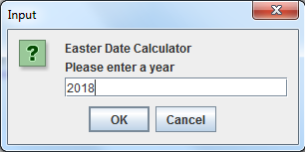

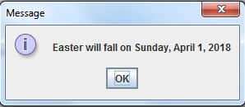

/*

* Justin Mendes

* Created: July 29, 2017

* Last Edited: September 14, 2017

* Unit 1 Activity 1 Program/Question 3

* This program will find the square of the square root of any number and find the round-off error in the number

*/

**import** javax.swing.JOptionPane;

**public** **class** RoundingError

{

**public** **static** **void** main(String[] args)

{

//Variable Declarations and Initializations

**double** number;

number = Double.*parseDouble*(JOptionPane.*showInputDialog*(**null**,"Please input a number", "Input", JOptionPane.***QUESTION_MESSAGE***));

System.***out***.println("The square of the square root = " + Math.*pow*(Math.*sqrt*(number), number));

System.***out***.println("The round off error = " + (number - Math.*pow*(Math.*sqrt*(number), number)));

}//end main

}//end class

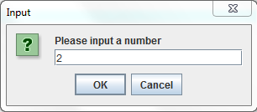



**import** java.text.DecimalFormat;

**import** java.util.Scanner;

**import** javax.swing.JOptionPane;

/*

* Justin Mendes

* Created: July 29, 2017

* Last Edited: September 15, 2017

* Unit 1 Activity 1 Program/Question 4

* This program will calculates the area of a scalene triangle using either Heron's formula or using trigonometry.

*/

**public** **class** AreaOfTriangle

{

**public** **static** **void** main(String[] args)

{

//for restart function

**int** restart = 1;

**while** (restart == 1)

{

//Variable Declarations and Initializations

**double** sides[] = **new** **double**[3], area;

**int** method;

DecimalFormat twoDigit = **new** DecimalFormat(",###.##");

Scanner sc = **new** Scanner(System.***in***);

method = Integer.*parseInt*(JOptionPane.*showInputDialog*(**null**,"Choose which method you would like to use/n"

+ "to calculate the area of the scalene triangle\n\n1 - Heron's Formula\n2 - Trigonometry", "Area Method", JOptionPane.***QUESTION_MESSAGE***));

**for**(**int** i = 0; i < 3; i++)

{

sides[i] = Double.*parseDouble*(JOptionPane.*showInputDialog*(**null**,"Please enter side " + (i + 1) + " of the SCALENE TRIANGLE"

+ "\n(no two sides should be the same!)", "Scalene Input", JOptionPane.***QUESTION_MESSAGE***));

}//end loop

System.***out***.println("Area of Triangle\n=================");

**if** (sides[0] + sides[1] > sides[2] && sides[0] + sides[2] > sides[1] && sides[1] + sides[2] > sides[0] &&

sides[0] != sides[1] && sides[1] != sides[2] && sides[2] != sides[0])

{

**switch**(method)

{

**case** 1: area = *calcHeron*(sides);

**break**;

**default**: area = *calcTrig*(sides);

}//end switch

System.***out***.println("The area of the " + sides[0] + "x" + sides[1] + "x" + sides[2] + " triangle is: " + twoDigit.format(area) + "units\u00B2");

}//end if

**else**

{

System.***out***.println("These sides can NOT make a SCALENE triangle.");

}//end else

System.***out***.println("\nPlease press 1 to try again\nPress anything else to exit");

restart = sc.nextInt();

}//end restart loop

}//end main

**public** **static** **double** calcHeron(**double**[] sides)

{

**double** semiP = 0, inSqrt;

System.***out***.println("Heron's Formula way:\nThe square root of s(s - a)(s - b)(s - c), Where semiperimeter = s = (a + b + c) / 2");

System.***out***.println("s = (" + sides[0] + " + " + sides[1] + " + " + sides[2] + ") / 2");

semiP = (sides[0] + sides[1] + sides[2]) /2;

System.***out***.println("s = " + semiP);

// \u221A is the symbol for square root which only works with text file encoding UTF-8

System.***out***.println("area = \u221A" + semiP + "(" + semiP + " - " +sides[0] + ")(" + semiP + " - " +sides[1] + ")(" + semiP + " - " +sides[2] + ")");

inSqrt = semiP * (semiP - sides[0]) * (semiP - sides[1]) * (semiP - sides[2]);

System.***out***.println("area = \u221A" + inSqrt);

System.***out***.println("area = " + Math.*sqrt*(inSqrt));

**return** Math.*sqrt*(inSqrt);

}//end method calcHeron

**public** **static** **double** calcTrig(**double**[] sides)

{

**double** angle = 0, inBracket;

System.***out***.println("Trigonometry way:\n(a + b + Sin(C)) / 2");

System.***out***.println("C = cos-1((a\u00B2 + b\u00B2 - c\u00B2) / 2ab)");

// \u00B2 unicode for squared superscript

System.***out***.println("C = cos-1((" + sides[0] + "\u00B2 + " + sides[1] + "\u00B2 - " + sides[2] + "\u00B2) / 2(" + sides[0] + ")(" + sides[1] + ")");

//SOLVING FOR C with COSINE LAW

angle = Math.*acos*((Math.*pow*(sides[0], 2) + Math.*pow*(sides[1], 2) - Math.*pow*(sides[2], 2)) / (2 * sides[0] * sides[1])) * 180 / Math.***PI***;

// *180/PI is needed to convert the radian into degrees (that comes from Math.acos function)

System.***out***.println("C = " + angle + "\u00B0");

// \u00B0 unicode for degrees

System.***out***.println("area = (" + sides[0] + " + " + sides[1] + " + Sin(" + angle + "\u00B0)) / 2");

inBracket = sides[0] + sides[1] + Math.*sin*(angle);

System.***out***.println("area = " + inBracket + " / 2");

System.***out***.println("area = " + (inBracket / 2));

**return** inBracket / 2;

}//end method calcTrig

}//end class

